

GM Parts
EPC

What’s New

Schedule V Enhancements, Phase II:
- "All Catalogs" Feature
- Alpha Index-to-Illustration Navigation
- Standard Parts Catalog Access from Illustrations
- Enhanced FIND Prompt/Features
- User-Added Illustration Notes
- Enhanced User Note Accessibility
- Enhanced Price/History Information Screen/History Indicator

Additional Enhancements:
- List Prices Available at Part Text
- Improved VIN Filtering and Display

Contents
1 "All Catalogs" Feature 3
2 Alpha Index-to-Illustration Navigation 5
3 Standard Parts Catalog Access from Illustrations 5
4 Enhanced FIND Prompt/Features 6
5 User-Added Illustration Notes 9
6 Enhanced User Note Accessibility 11
7 Enhanced Price/History Information Screen/History Indicator 12
8 List Prices Available at Part Text 14
9 Improved VIN Filtering and Display 15

Copyright Notice
Information in this document is subject to change without notice. This document and any associated art work, software, product designs or design concepts are copyrighted with all rights reserved. Under the copyright laws, this document or designs may not be copied, in whole or in part, without the prior written consent of Bell & Howell Publishing Services. Under the law, copying includes translation to another language or format.
Copyright © 2001 Bell & Howell Publishing Services. All rights reserved.
Microsoft, MS, and Windows are registered trademarks of Microsoft Corporation.
Documentation Feedback
At Bell & Howell, we strive to provide high-quality, easy-to-use printed and online manuals, guides, and instructional material. We continually work to improve the effectiveness and usability of our existing documentation, while developing new ways to help you get the most out of your Bell & Howell product.
Learning about your experience with this document is critical to our documentation efforts. Is it effective? Difficult to use? Were you able to quickly find the information you need? The answers to questions like these are very important to us. We welcome all feedback about our documentation products. Please email your comments or suggestions directly to our Technical Communications Department at: documentation@ps.bellhowell.com. Try to provide as much of the following information as possible:
- Your name, address, and phone number (optional).
- The name of your Bell & Howell product.
- The document type (printed or online).
- The document’s part number, revision number, and/or publication date.
Please remember that this email address is intended for documentation concerns only, and not for technical support or customer service. We look forward to hearing from you!

Important Information (pease read this first).
All GM Schedule V enhancements apply to CD/DVD media, and only apply to the following platforms: Windows 95 or above, and UNIX with W/98 PC Clients (non-Reflections) or above. If you have a Windows 3.11 or UNIX with X-terminals you will not have access to these enhancements.
1 "All Catalogs" Feature
An All Catalogs feature has been added to the Make screen. All Catalogs allows the user to view an index of all catalogs available through the GM Parts EPC. Once a catalog is selected, you can view all data found within the catalog.
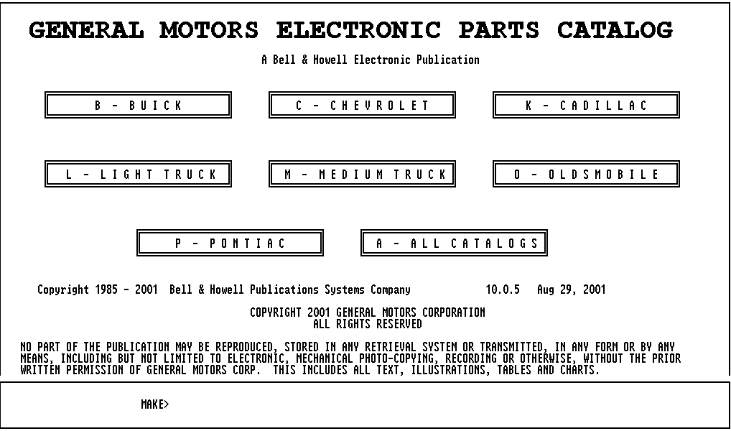
From the Make screen, click A - All catalogs, or type A, then press ENTER, to display the Catalog Index:
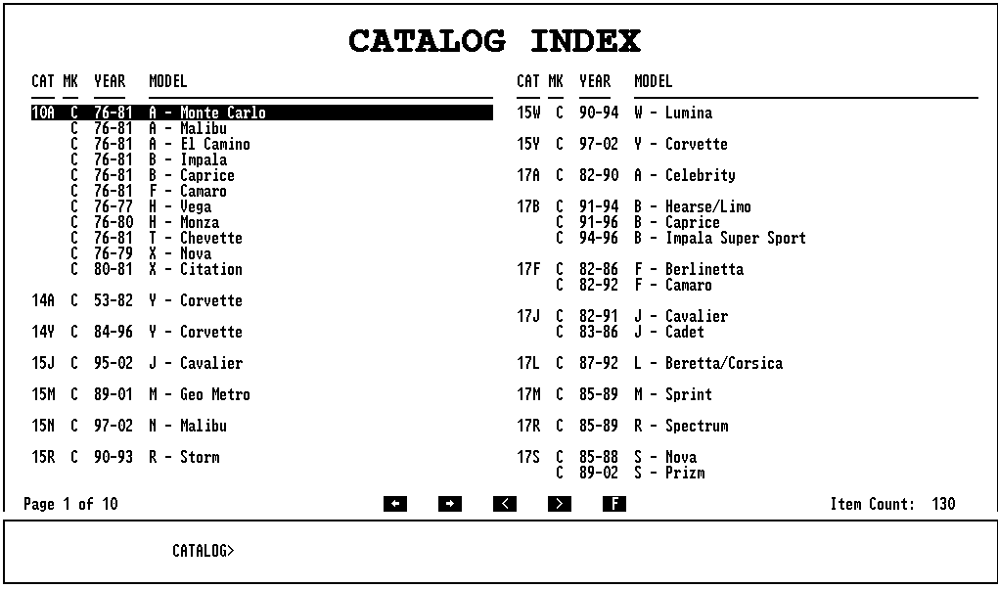
Page 1 of 10 (lower left-hand corner) indicates that the index occupies 10 pages. Use the Menu Bar arrows, the onscreen arrows, or the keyboard arrow keys to scroll between pages.
Item Count: 130 (lower right-hand corner) indicates that the index contains 130 items.
Double-click a catalog number in the CAT column, or type a catalog number, then press ENTER, to display the Group Index. The Group Index contains parts data for all years and models for the selected catalog.
2 Alpha Index-to-Illustration Navigation
The GM Parts EPC now offers the capability to go directly from an Alpha Index to an illustration.
- From the Alpha Index, highlight an item, then select Illustration from the Goto menu, or use the Illx key [F6], to display the illustration containing that part name and group. The part name is highlighted on the part text display, and the part's callout number is highlighted on the illustration.
Note: If the part appears in more than one illustration, an Illustration Index appears before the illustration is displayed. Simply select an item from the list to go to that illustration.
- To access an Alpha Index from a Part Group Index, press ENTER without typing anything at the Part Name prompt to display the Alpha Index for the entire group.
Note: Press ENTER at the Part Name prompt, without typing a part name, to display an Alpha Index of all parts within the group.
3 Standard Parts Catalog Access from Illustrations
You can now go directly to Standard Parts Catalog pages from illustrations.
- Standard parts are selected in the same way as other parts. Click on or type a part callout number. The number appears in the Input Window. If the callout is a standard part, a notification will appear near the bottom of the screen:
- Press ENTER, or click the right mouse button, to display text for the last callout you selected.
If the callout you selected is a standard part, the Standard Parts Catalog page containing the part appears. If no data on a standard part is found, the Standard Parts Index appears, with the first part in the part's subgroup highlighted.
Standard Part Catalog pages also offers full access to the enhanced FIND prompt described in the following section, including the Search for Text and Filter on Text options.
4 Enhanced FIND Prompt/Features
The Find Prompt has been enhanced to provide greater search flexibility. You can search for a particular text string or use a text filter to display only entries containing that text. The Find Prompt is accessible from many locations in the EPC. An F button appears near the bottom of the screen when the prompt is available:
To use the enhanced Find Prompt:
- Click the F button, select Filter from the Find menu, or press HOME to display the prompt.
- Click Search for Text to place a checkmark next to the option, then type the text for which you are searching. For example, we typed DURA:
- Press ENTER. The EPC searches the text and highlights the first occurrence of DURA:
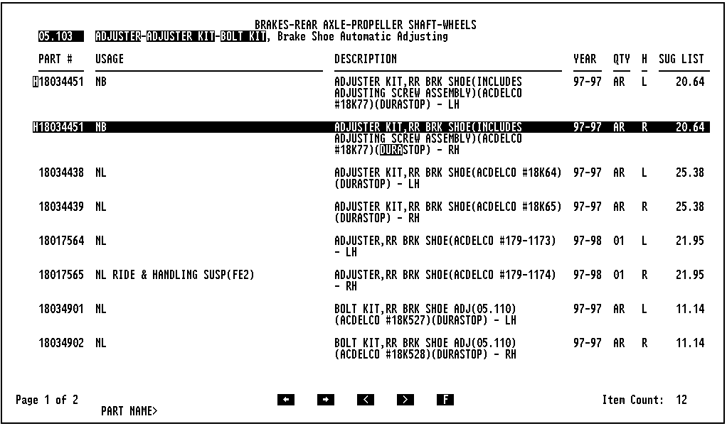
- Press CTRL+F to scroll to the next occurrence of the text screen or CTRL+R to scroll to the previous occurrence.
- To filter the text to display only entries that contain the text string you typed, click the F button, select Find from the Filter menu, or press HOME to re-display the Find Prompt.
Note: Click Cancel to undo a previous filtering action. Any filtered-out records will reappear.
- Now, reopen the Find prompt, then click Filter on Text to place a checkmark next to the entry:
- Press ENTER to display only entries containing DURA. Notice that, in this example, the Item Count (lower left hand corner of the screen) has been reduced from 12 entries, to just six.
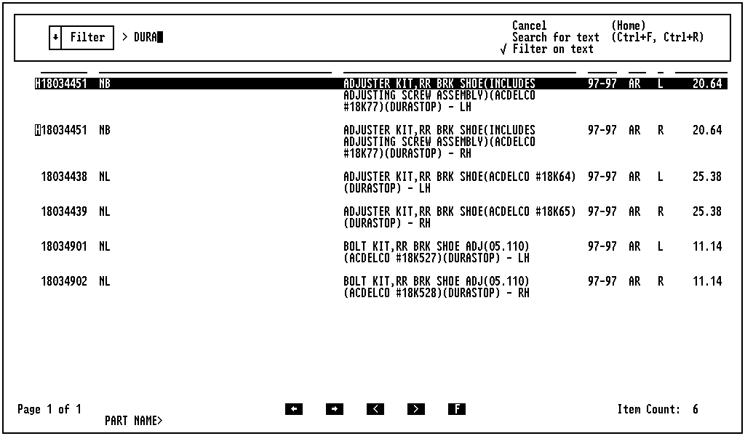
You can also filter text with AND, OR, or NOT delimiters.
- To use AND, type two or more filter items, separated by commas. For example, type BOLT,SHOE to filter to records containing both BOLT and SHOE.
- To use OR, type two or more filter items, separated by backslashes. For example, type BOLT\SHOE to filter to records containing either BOLT or SHOE.
- To use NOT, precede the filter text with a tilde (~). For example, reopen the Find prompt, make sure Filter on Text is selected, then type ~DURA:
Press ENTER to display parts that do not contain DURA:
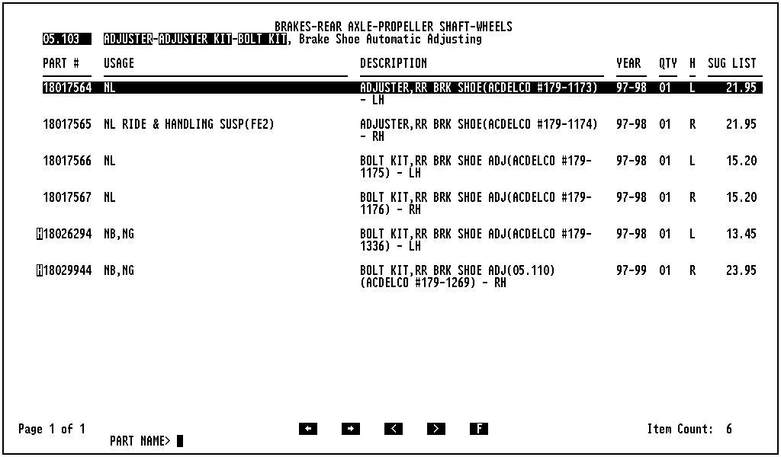
Filter options can be used in any combination. For example, type BOLT\SHOE,~DURA to filter to records containing BOLT and SHOE, but not DURA.
You can access previously-entered text without retyping it. To do so, click the down arrow next to the prompt, or press TAB to highlight the prompt, then press ENTER. A pop-up window containing the list of previously entered text items appears:
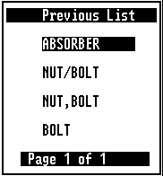
Click an item, or highlight an item, and then press INSERT to search for, or filter on, that text.
5 User-Added Illustration Notes
You can now attach up to three user-added notes to any illustration accessed from the Illustration Index. Each note can contain up to 80 characters. Notes can also be changed, deleted, or printed (see Table 1).
To add a note to the illustration currently displayed on the screen:
- Select User Added Notes from the Part Info menu or use the Memo key [CF5] to open the User Added Note Menu:
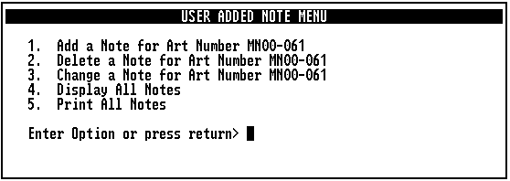
- Click 1. Add a Note for Art Number xxxx-xxx, or type 1, then press ENTER to display an Enter Text prompt:
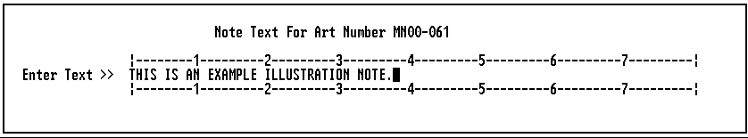
- Type your note (up to 80 characters), then press ENTER.
- Press ENTER again to close the User Added Note Menu. The illustration note is now displayed near the top of the part text display.
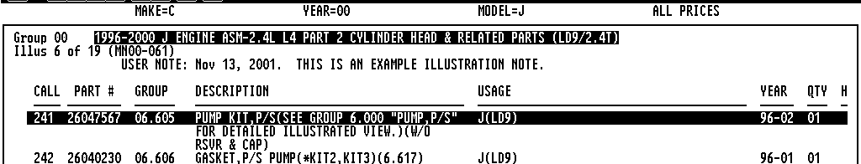
Note: If necessary, select Image On/Off from the Image menu or use the IMG TXT key [F12] to hide the illustration and display the entire note.
Table 1: User Added Note Menu Options
Option | To Use
Add a Note | - Select Option 1.  - Type the note at the prompt, then press ENTER.
Delete a Note | - Select Option 2.  - Select a note, then press ENTER to delete it.
Change a Note | - Select Option 3.  - Select a note, then press ENTER.  - Type the new text for the note, then press ENTER.
Display All Notes | Select Option 4 to display all available notes in chronological order, with the most recent at the top of the list.
Print All Notes | Select Option 5, then follow the onscreen prompts to print all available notes.

6 Enhanced User Note Accessibility
User Notes are now accessible from virtually anywhere in the EPC, rather than from part text displays only, as has been the case in the past. For instance, you can now display notes from the Make screen or from the Standard Parts Catalog.
To display the User Added Note Menu, select User Added Notes from the Information menu, or use the Memo key [CF5]:
From some locations, notes can only be displayed or printed. When this is the case, the User Added Note Menu contains just two options:
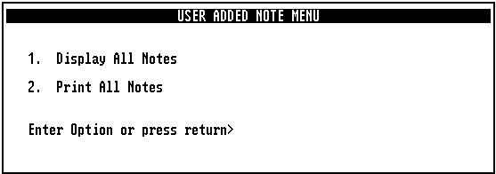
7 Enhanced Price/History Information Screen/History Indicator
The Price/History Information screen now displays a variety of additional pricing information. This information is available from any screen that displays part numbers, including charts, side-by-side illustration/text pages, medium-duty truck broadcast sheets, and Additional Catalog part displays in catalogs such as Standard Parts, Durastop Parts, and ACDelco Parts.
Parts with history are indicated by an H symbol immediately preceding the part number.
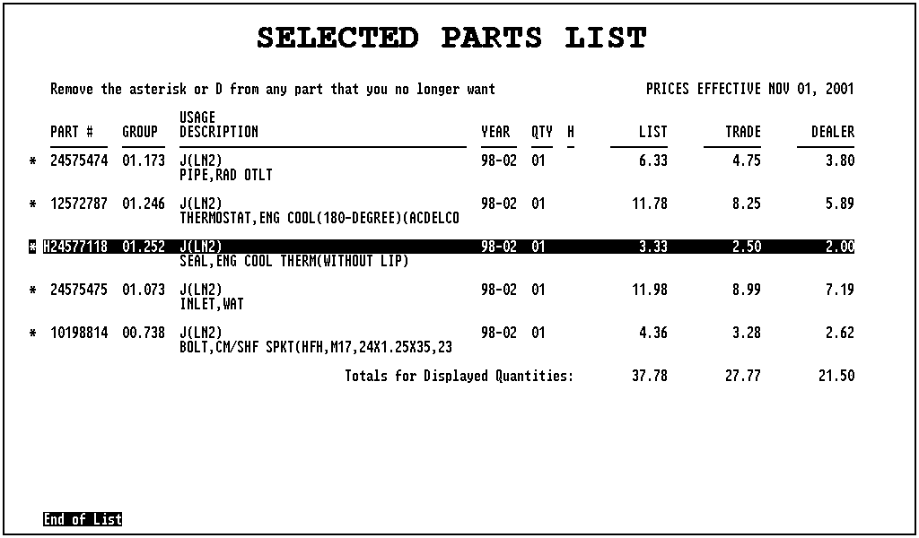
Parts with history are indicated with an H symbol.
To view the Price/History Information screen for a part, click the part number to highlight it, then select History from the Part Info menu or use the HIST key [F9]. The Price/History Information screen for the highlighted part number appears:
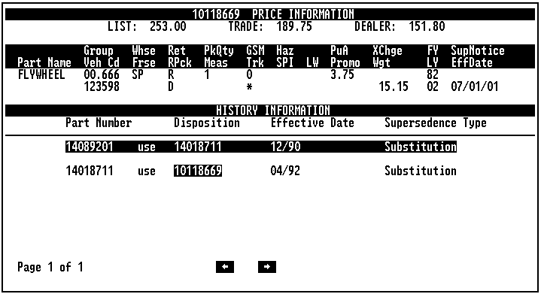
The Price/History Information screen displays list, trade, and dealer prices, additional pricing information, and supersedence history for that part. The screen is also accessible, in the same manner, directly from your Review List.
If the part number you looked up does not appear at the end of the supersession chain, you can display price information for the most recent part. To do so, highlight the part number, then press F9.
Parts without the H indicator do not have history. You can, however, view pricing information for these parts. To do so, highlight the part number, then select History from the Part Info menu or use the HIST key [F9]. The Price Information screen for the highlighted part number appears:
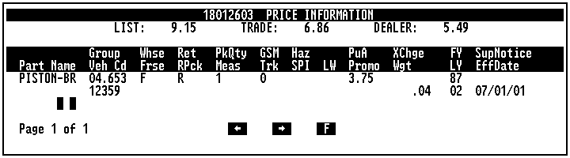
8 List Prices Available at Part Text
Suggested list prices for each part in a subgroup are now displayed at part description screens.
Note: The first time, you use the new CD/DVD, this feature is set to OFF. See the section below to toggle the feature to ON.
To access a part description screen from a Part Group Index, double-click a subgroup, or highlight a subgroup, then press ENTER. The part description screen appears, with the suggested list prices displayed in a column at the right-hand side of the screen.
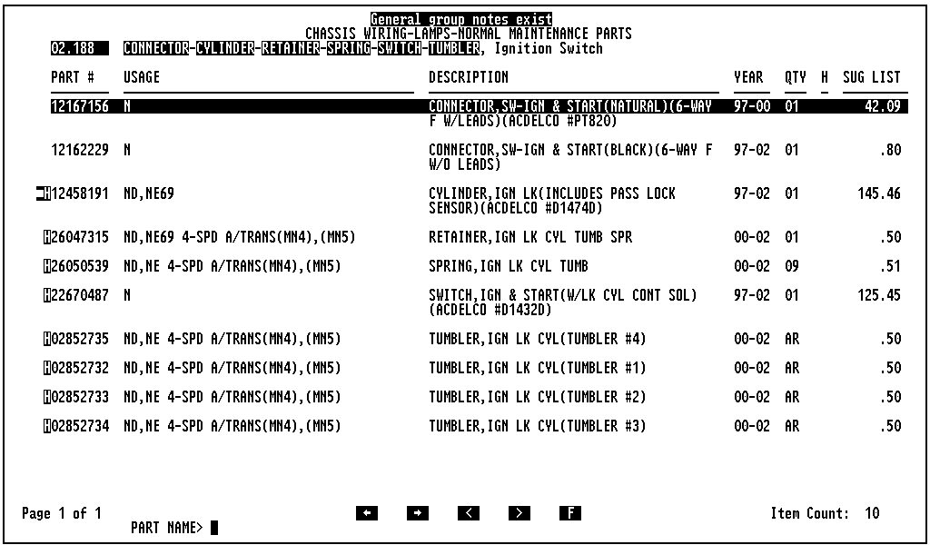

Displaying or Hiding the Suggested List Prices
If suggested list prices don't appear at a part description screen, or you wish to hide the prices from view, you can toggle the display on or off at the List Utility screen. To do so:
- Select List Utility from the Review List menu, or use the Save List key [CF7] to display the Save List Options menu.
- Select 6. Utilities, or type 6, then press ENTER, to open the User Utilities menu.
- Select 2. Suggested List Price in Part Text, or type 2, then press ENTER, to toggle the option to ON or OFF.
- Press ENTER to close the List Utility screen.
Note: You may have to leave and then re-enter the current part text screen for the changes to take effect.
9 Improved VIN Filtering and Display
Note: The enhancements described in this section were not originally part of Schedule V enhancements. They are provided by Bell & Howell as an added feature. These enhancements are available only for 1990–present VINs.
VIN filtering in the EPC has been significantly enhanced to allow for improved accuracy and fewer part records returned from part searches. Previously, parts were filtered according to vehicle model and year. With these enhancements, parts are now also filtered according to body style, series code, and RPO applicability.
Filtering capability has also been enabled at Illustration Indexes. Now, only illustrations applicable to the current VIN are listed in the index.

Using VIN Filtering
To demonstrate the new capabilities we'll use VIN 1G1JC5249Y7123123 (a 2000 Chevrolet Cavalier). To access and use the VIN screen:
- Select VIN/RPO from the Information menu, or use the VIN/RPO key [F12] to display a VIN prompt:
- At the VIN prompt, type an entire VIN, or the last 6 digits of a VIN and a 4-digit year:
- Press ENTER. If you typed the last six digits of a VIN, a VIN Match List appears. Select a VIN from the list to display the VIN screen. If you typed the entire VIN, the VIN screen appears immediately:
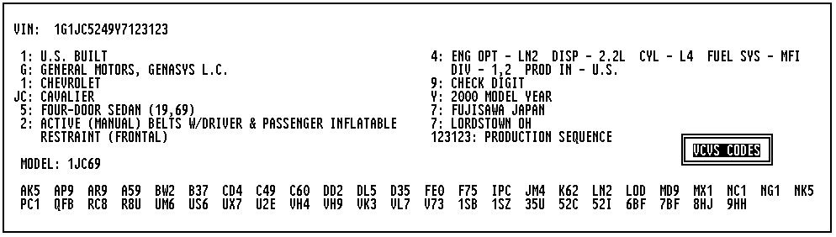
A highlighted VCVS Codes button provides access to the VCVS Codes screen. Applicable RPO Codes are displayed near the bottom of the screen. Click a code to view its description.
- From the VIN screen, press ENTER to set the catalog and go to the vehicle's Group Index.
- Select 14 Interior Trim - Seat Belts to display its Part Group Index, then select subgroup 14.896 to display the part description screen for that subgroup. With VIN Filtering turned ON, only one part record is returned for this search:
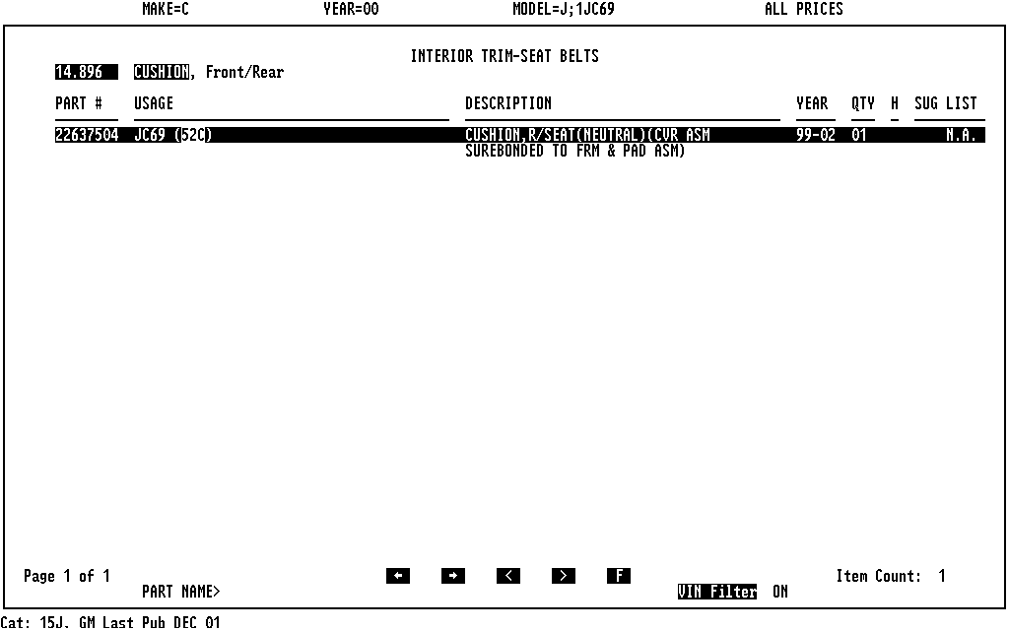
With VIN Filtering ON, the list contains only one entry.
- A highlighted VIN Filter button at the bottom of the screen indicates that VIN filtering is currently ON. Click the button to toggle VIN filtering to OFF. The screen now contains all items for the group. The number of items on the list increases to 14:
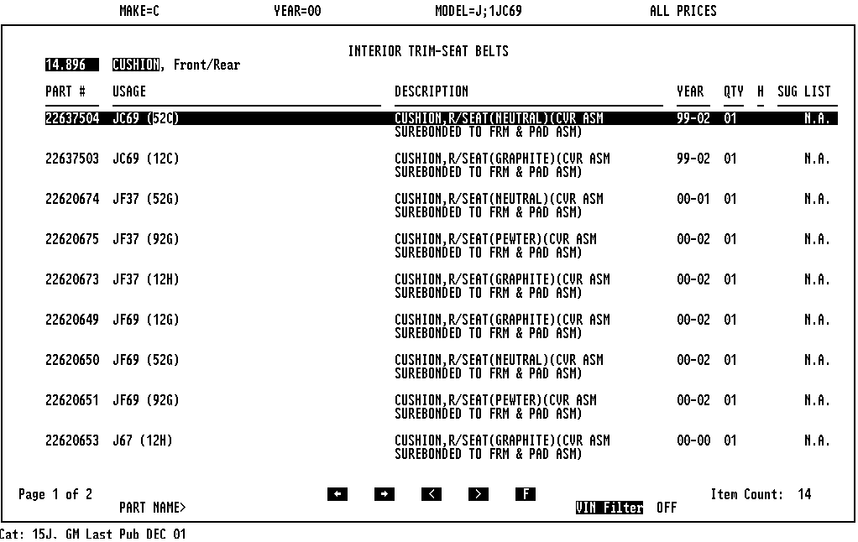
Page 1 of 2 (lower left-hand corner of the screen) indicates that the list occupies 2 pages. Item Count: 14 (lower right-hand corner) indicates that the list contains 14 entries. Any applicable RPO codes are highlighted on the list.

